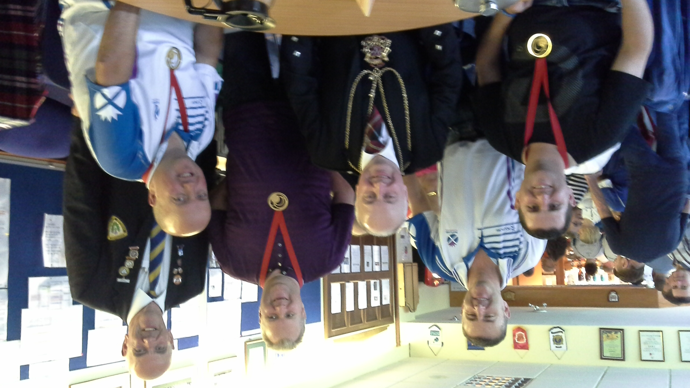

The final qualifying stages on Friday evening and Saturday morning provided some very exciting play with the local players enjoying some success against the Internationalist from the Commonwealth Games squad.

In the last analysis however in the ladies section the strength of the Commonwealth Games players shone through with the pair comprising Anne Dunwoodie and Lorraine Malloy prevailing in the final against Becky Craig and Michelle Cooper by 17 shots to 9.

The men's semi finals proved much different with two local teams Stewart Massie and Michael Presly and Rory Thomson and Kevin Philip meeting in one semi and two Commonwealth Games teams in the other.

Rory Thomson of the Woodend Club and Kevin Philip of the home Whitehall Club won through to meet internationals David Gourlay and David Peacock in the final.

In a keenly contested match the internationals again showed their class running out 17 shots to 10 to lift the gents' trophy

The final day was dogged by very difficult weather conditions and it is of great credit to the host Club that the green was able to withstand the torrential showers and allow the players to produce some stunning bowls throughout the day.

On a social level the Club was honoured on Saturday afternoon by a visit from the Lord Provost of Aberdeen who spent some considerable time chatting with the international players and the spectators.



